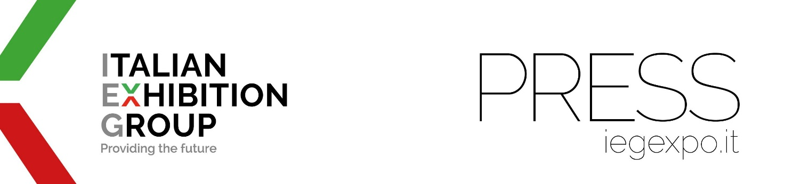

press release
(English translation)

IEG ASIA, THE BEST ITALIAN SME IN SINGAPORE:
AN AWARD FROM THE ITALIAN CHAMBER OF COMMERCE SINGAPORE (ICCS)

- The Italian Chamber of Commerce in Singapore rewards Italian Exhibition Group's (IEG) subsidiary in South-East Asia for fostering economic cooperation between Italy and Singapore
- And the additional announcement that, for the second year running, IEG is the only Italian company among the world’s top 27 exhibition organisers according to the Stax ranking
Singapore, 25th September 2024 - The Italian Chamber of Commerce in Singapore (ICCS) has awarded IEG Asia Pte. Ltd., an Italian Exhibition Group (IEG) subsidiary, during the ICCS Business Awards ‘24, with “Best Italian SME in Singapore”. The prestigious initiative highlights the role of businesses in promoting international relations and economic collaboration between Italy and the Lion City.

REASONS FOR THE AWARD
The jury awarded IEG Asia for its investment in Singapore's MICE (Meetings, Incentives, Conferences and Exhibitions) sector, especially through Sigep Asia and SIJE, and for its commitment to shaping the business landscape of the Lion City and promoting collaboration with Italy. Receiving the award in the presence of Italian Ambassador to Singapore, Dante Brandi, Director of the Italian Trade Agency (ITA) in Singapore, Giorgio Calveri, and leaders and representatives of the Italian and Singaporean business communities were Ilaria Cicero, CEO of IEG Asia, and Francesco Santa, IEG’s International Business Development Director. Carlo Costa, CCO of IEG, was also in attendance.

STATEMENTS AND DATA
“I would like to thank ICCS and those who have supported IEG Asia on this road to growth in a city where more and more Italian companies are alighting and which is the most important economic hub in the whole ASEAN area,” said Ilaria Cicero. “In little more than a year, IEG Asia has acquired events in the F&B, Ho.re.Ca. and Jewellery sectors from a local organiser and an international one, also with the support and consultancy of Algebra Pte. Ltd. of Singapore. We have faced numerous challenges, others await us: we will continue with tenacity and professionalism to expand our business in Singapore and the ASEAN countries.”
“This award is an honour. It confirms our commitment to bringing Italian excellence to the world, and to Singapore in particular, the primary destination for our country's exports to South-East Asia, which exceeded €2.8 billion (+16.9%) in 2023,” added Francesco Santa. “It is the result of our team’s work and passion and the trust and support of our partners and customers.”
“According to Ministry of Trade and Industry estimates, Singapore's economy grew by 2.7% in the first quarter of 2024: faster than the last quarter of 2023. This recognition is important,” Carlo Costa underlined, “also in light of these numbers. It proves that the ‘IEG spirit’, which encourages us to face the market with curiosity, professionalism, teamwork and attention to detail, is a winning one, even when a long way from our headquarters, which are always firmly connected to all the Group's offices.”

BEYOND SINGAPORE: IEG IS THE ONLY ITALIAN COMPANY IN THE STAX GLOBAL RANKING
And in the meantime, yet another important acknowledgement is reported: for the second year running, Italian Exhibition Group is the only Italian company among the world’s top 27 trade show players included in the prestigious Stax ranking - a global strategy consulting firm - based on turnover produced exclusively by the organisers' direct exhibitions. Another significant fact is that four of the top 27 positions in the ranking are held by industrial or commercial partners of IEG, which projects the Group's leading industries into strategic geographical areas such as the Middle East and the Americas. In fact, Informa, which Stax ranks as first, is a partner of IEG with JGTD show dedicated to the gold and jewellery supply chain. Also partnering with IEG are Koelnmesse (for Sigep China), while Deutsche Messe is IEG's partner in Mexico and Canada. Also on the list is Nürnberg Messe, which organises Focus on PCB at IEG's Vicenza Expo Centre.

PRESS CONTACT ITALIAN EXHIBITION GROUP | media@iegexpo.it
head of corporate communication & media relation: Elisabetta Vitali|
press office manager: Marco Forcellini, Pier Francesco Bellini | international press office coordinator: Silvia Giorgi | press office coordinator: Luca Paganin | press office specialist: Nicoletta Evangelisti, Mirko Malgieri

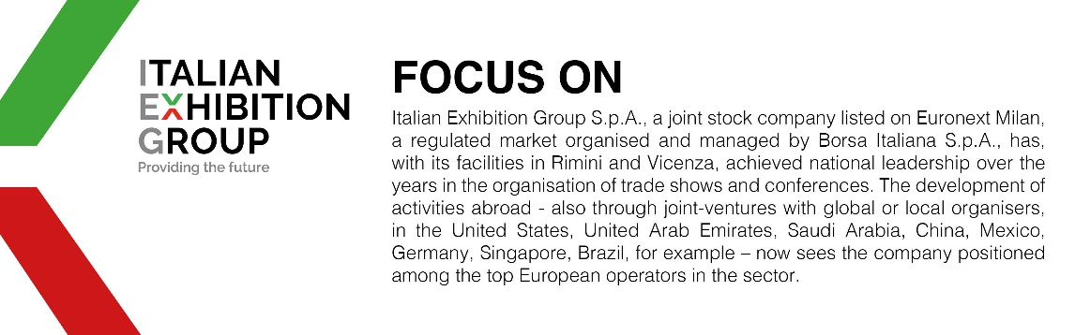

This press release contains forecast elements and estimates that reflect the management’s current opinions (“forward-looking statements”), particularly regarding future management performance, realization of investments, cash flow trends and the evolution of the financial structure. For their very nature, forward-looking statements have a component of risk and uncertainty, as they depend on the occurrence of future events. The effective results may differ (even significantly) from those announced, due to numerous factors, including, only by way of example: food service market and tourist flow trends in Italy, gold and jewellery market trends, green economy market trends; the evolution of raw material prices; general macroeconomic conditions; geopolitical factors and evolutions in the legislative framework. Moreover, the information contained in this release does not claim to be complete, and has not been verified by independent third parties. Forecasts, estimates and objectives contained herein are based on the information available to the Company as at the date of this release.

